**Project Topic :** Job Portal

**Group Members**

|  |  |  |
| --- | --- | --- |
| **Div** | **Roll no.** | **Name** |
| **B** | **407** | **PRAJAYSHEE CHAUHAN** |
| **B** | **436** | **GARGI PATHRUDKAR** |
| **B** | **450** | **RUPALI SINGH** |
| **B** | **438** | **SNEHAL PATTAM** |
| **B** | **432** | **OJASWI NANNAWARE** |
| **B** | **455** | **MANASI VEDPATHAK** |

**SCOPE OF THE SYSTEM**

1. Maintain job seeker and employer profiles.
2. Provide customized job postings.
3. Search job based on skills, company.
4. Manage job application status.
5. Maintain job details and generate various reports.

**Technology stack**

**List all front end, blackened technologies chosen for project :** Ruby and SQL LITE

**Proof of Concept**

1. **Add screenshot and code of sample UI developed using chosen front end technology.**

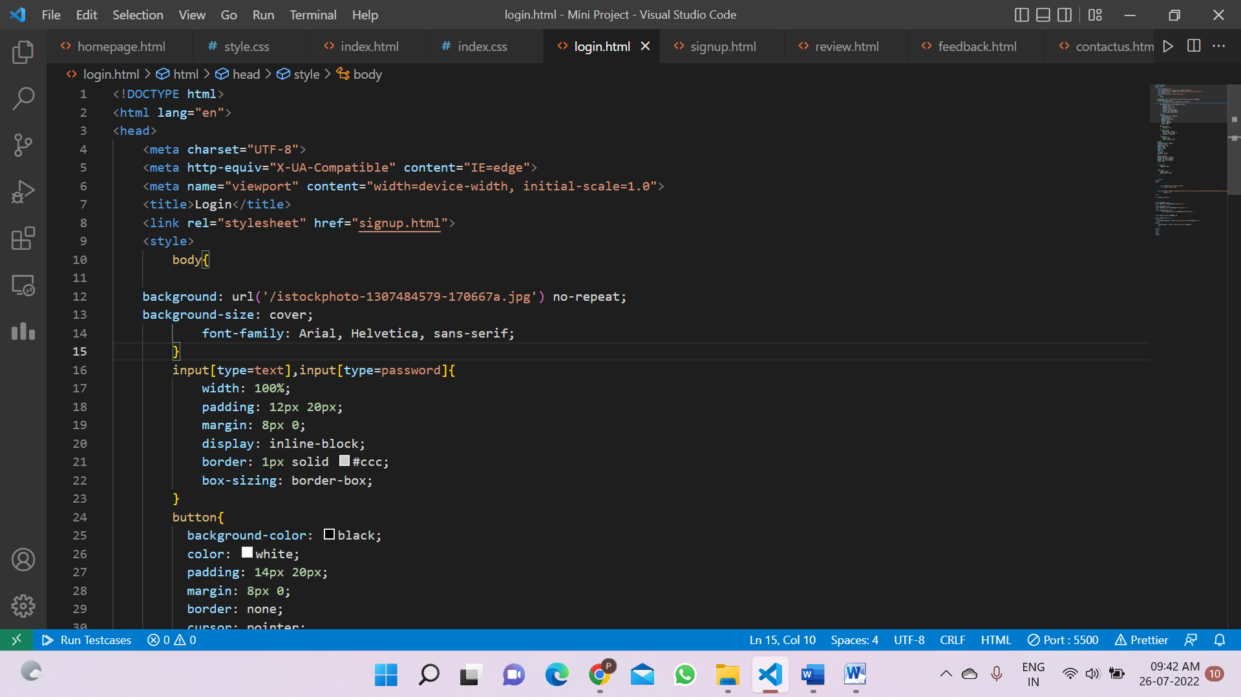

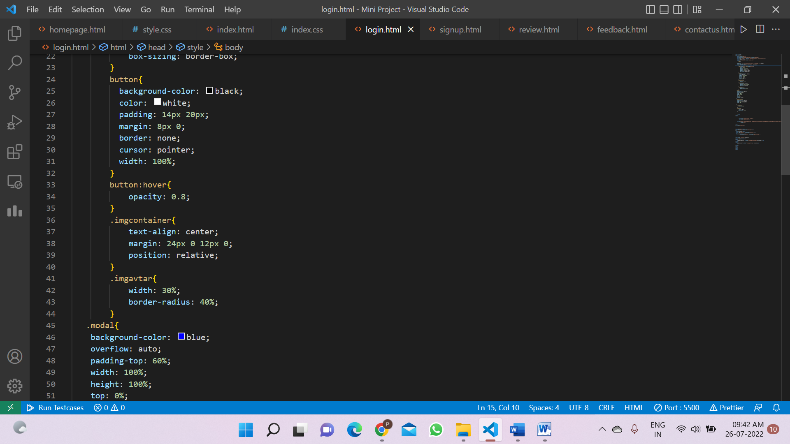

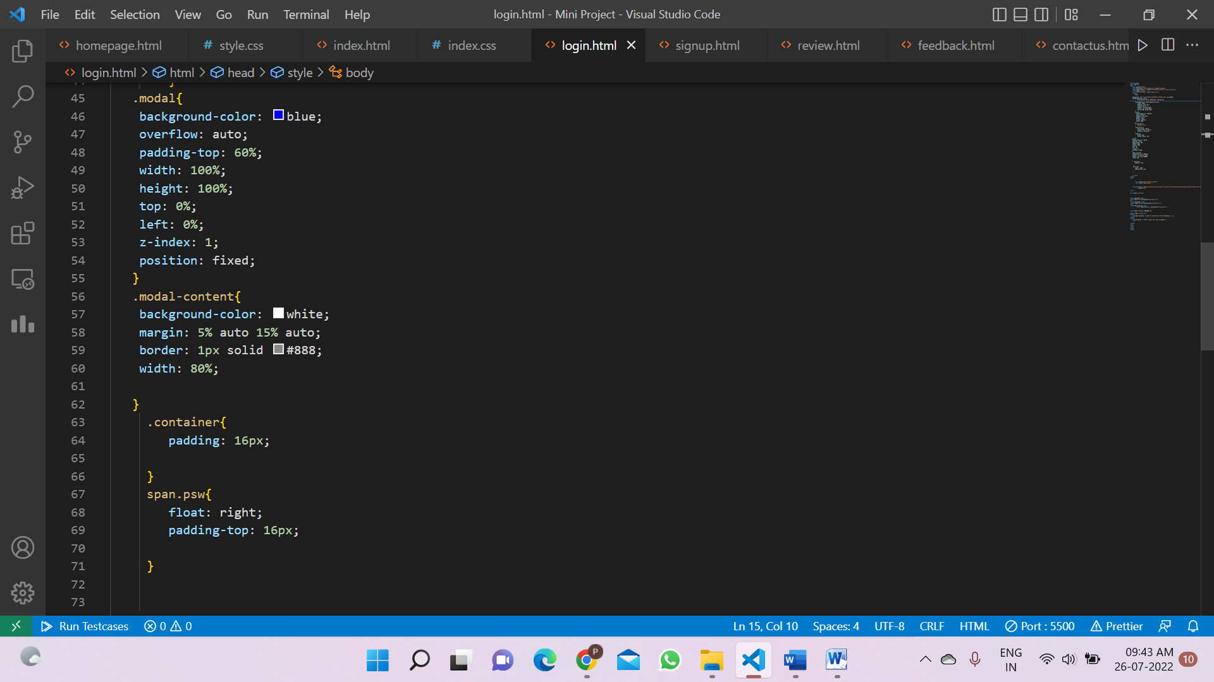

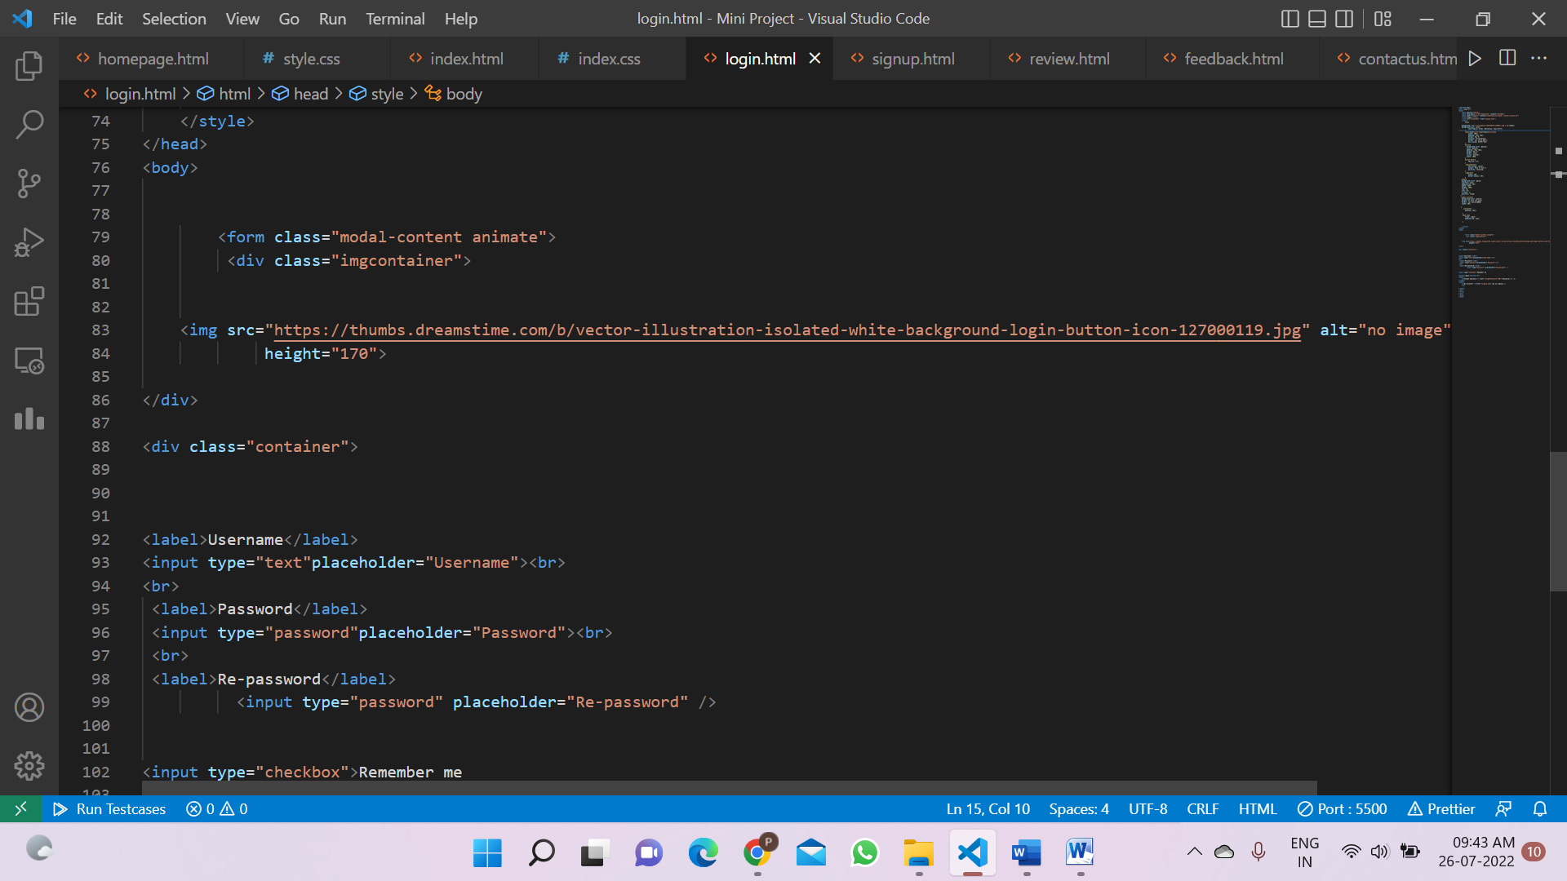

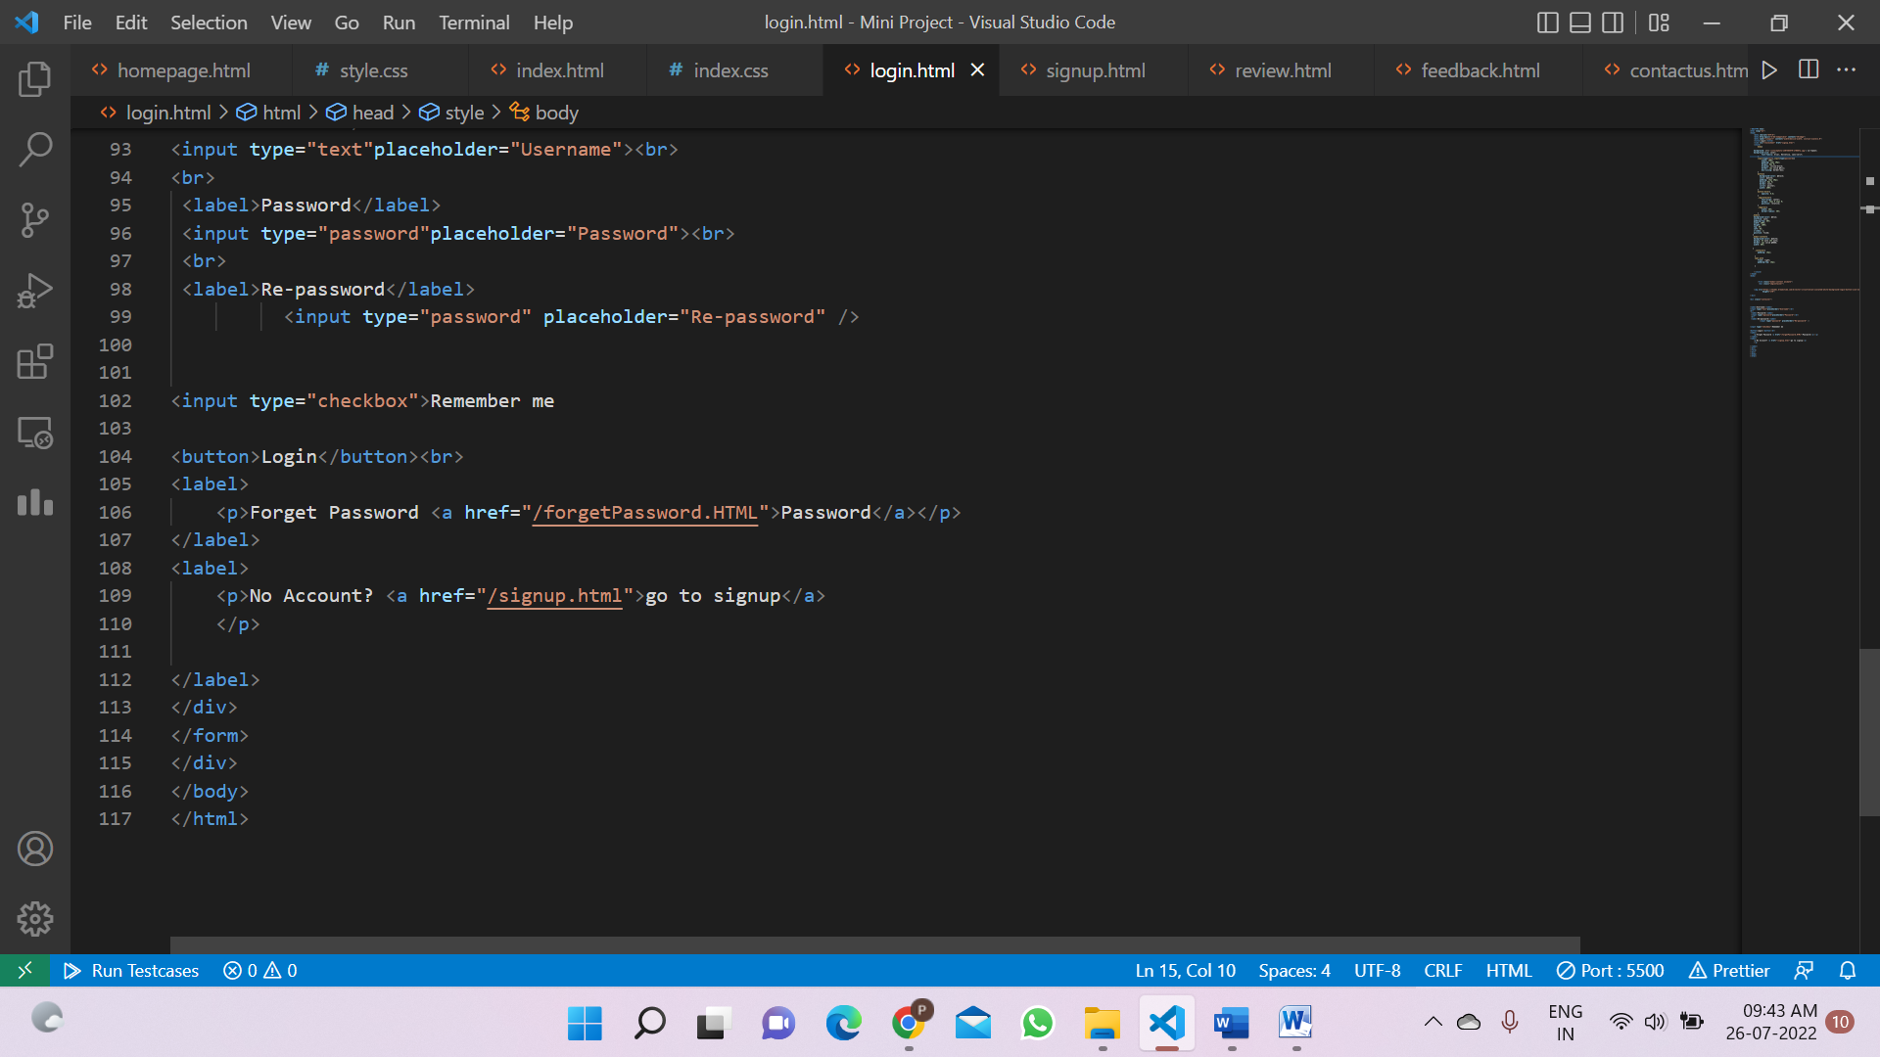

**OUTPUT:-**

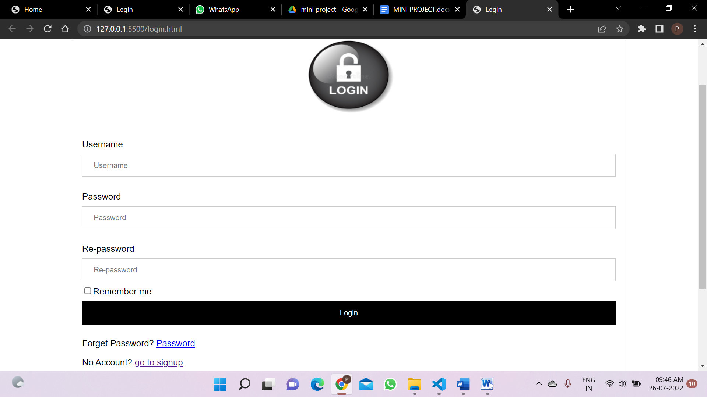

1. **Add screenshot and code of sample data stored in database**

Still working on it